1.

2.

3.

4.

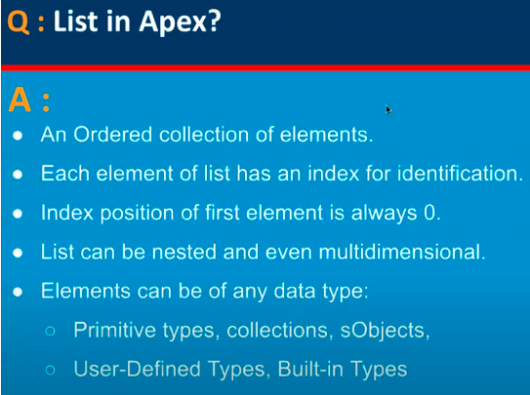

5.

6.

7.

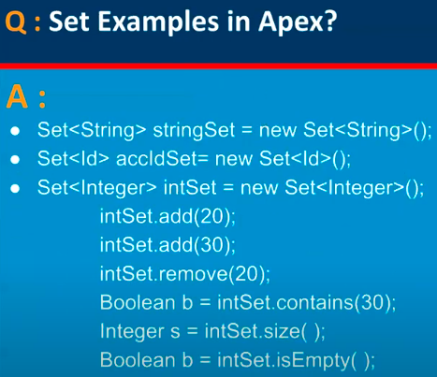

8.

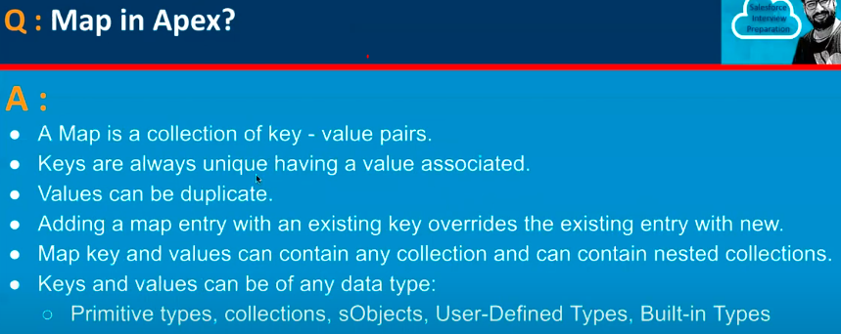

9.

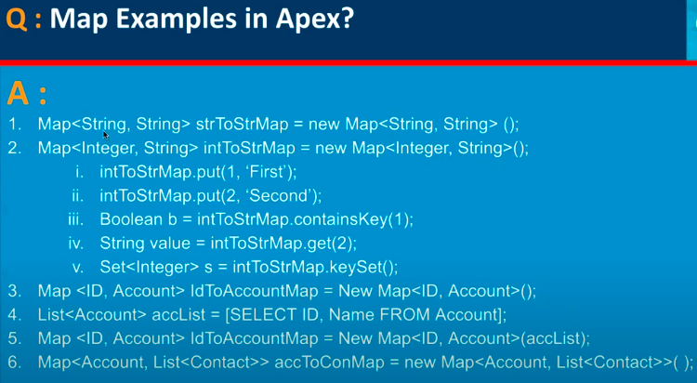

10.

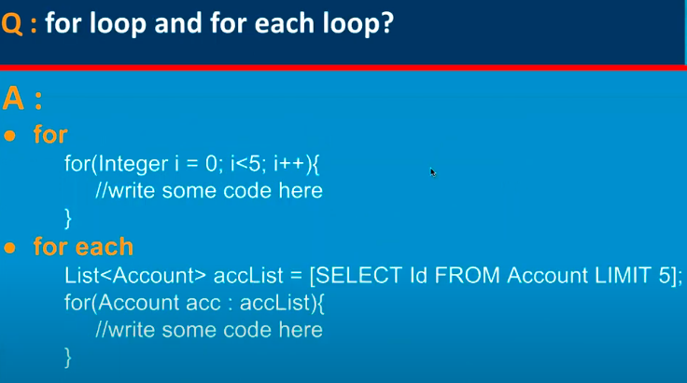

11.

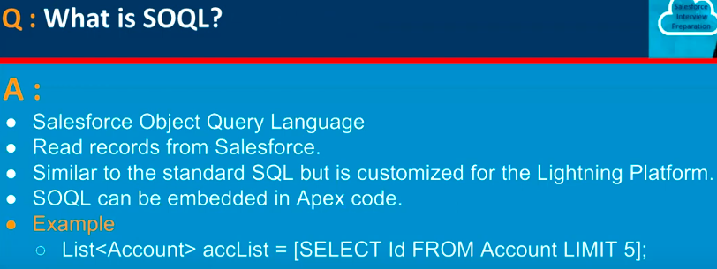

12.

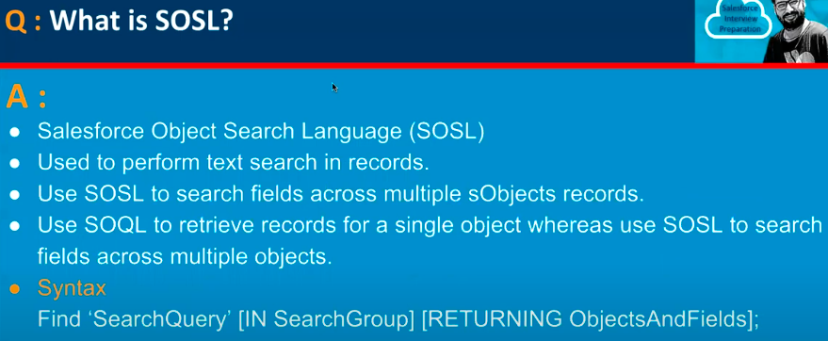

13.

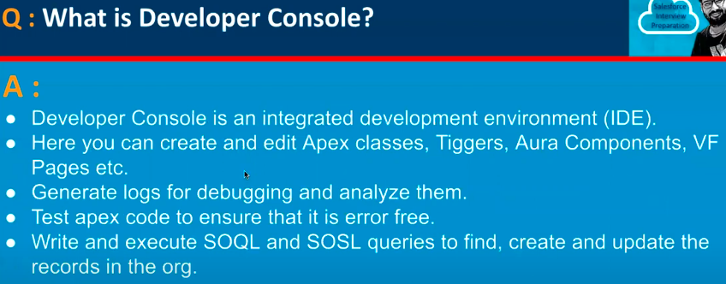

14.

15.

16.

17.

18.

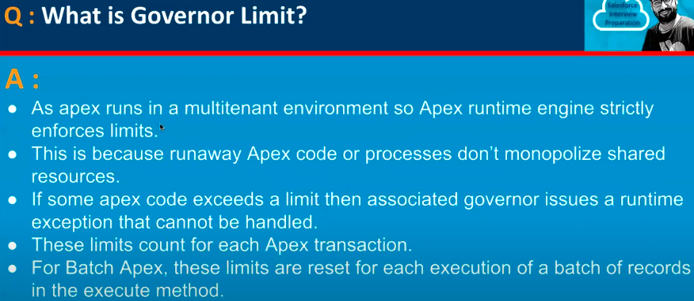

19.

20.

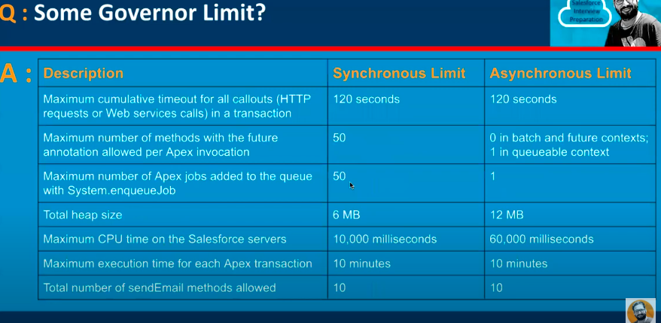

21.

22.

23.

24.

25.

26.

27.

